|  |  |
| --- | --- |
| Pie chart and stacks    Oracle XE Bookstore Database: User Roles, Data Population, and Security Monitoring | Members   * Erin David Cullen 600530 * Juan Oosthuizen 600161 * Tian Petrus Strydom 600318 * Zoë Janse Van Rensburg 601277 * Justin Scheepers 600245   **DBA381: Database Administration** |

Table of Contents

Installation & Configuration of Oracle Database 2

1.1 Operating System Used 2

1.2 Step-by-Step Installation Process 2

1.3 Configuration Adjustments 6

Configuration Settings 7

Organisational Requirements and Database Design 7

2.1 Organisational Requirements 7

2.2 Schema 8

2.4 Table Descriptions 10

2.5 Views Created 11

2.6 Indexes Created 12

Data Population and Query Execution 12

Data Population Process 12

Queries user_viewer.sql 13

Security Implementation 16

Monitoring and Troubleshooting 17

References 19

# Installation & Configuration of Oracle Database

### 1.1 Operating System Used

* **Operating System:** Windows 10 Pro (64-bit)
* **Oracle Version:** Oracle Database 21c
* **Host Environment:** Local physical machine / Virtual machine using Oracle VirtualBox
* **System Specifications:**
  + **Processor:** Intel Core i5 / i7
  + **RAM:** 8 GB
  + **Disk Space:** 100 GB
  + **Oracle Base Directory:** C:\app\oracle
  + **Database Name (SID):** BOOKDB
  + **Global Database Name:** bookstoredb

Oracle 21c was chosen because it is the current **long-term support (LTS)** release recommended for enterprise and academic environments. It provides stable performance, strong security features, and is widely used in production systems.

### 1.2 Step-by-Step Installation Process

**Step 1: Download Oracle Software**

Go to [Oracle Database Software Downloads](http://www.oracle.com/pls/topic/lookup?ctx=javase9&id=database_software_downloads) in your browser. 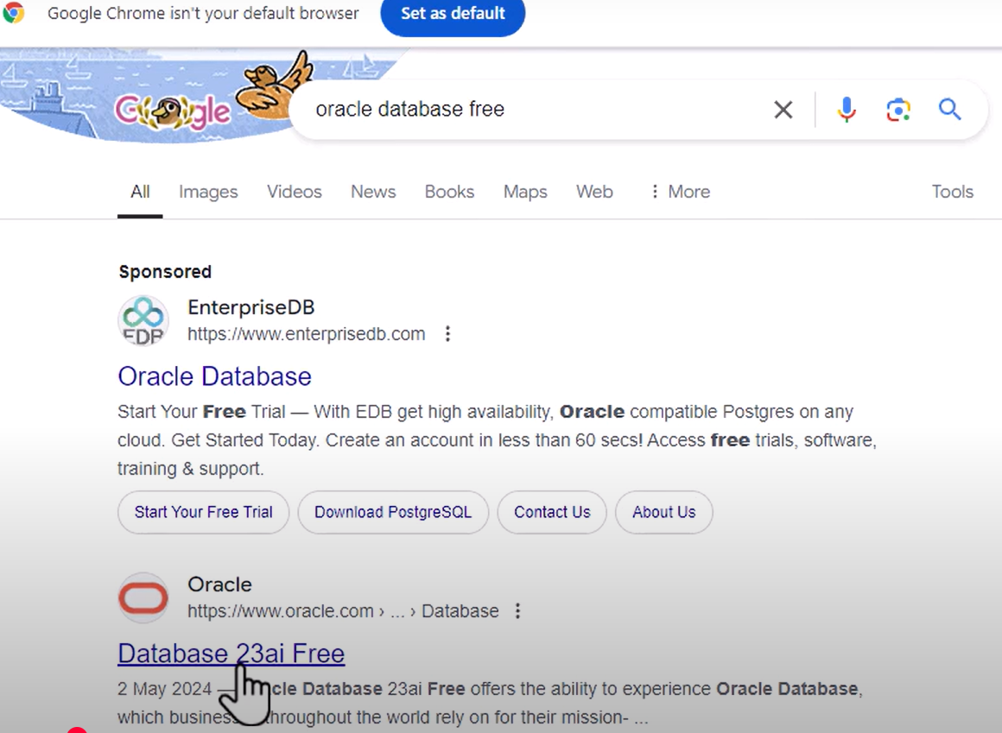

1. Or download the 64-bit .zip file. Select the.zip file to select
2. Extract All. Extract both the .zip files to the same folder. Note: Don’t extract the archive using unzip command, which may result in an unsuccessful run of the setup.exe.
3. 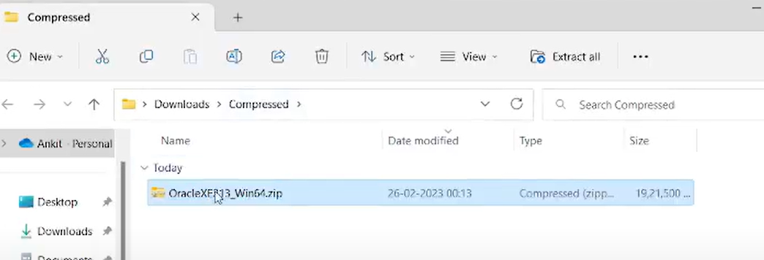

1. Run the setup.exe and select the installation options according to your database and Windows user requirements.

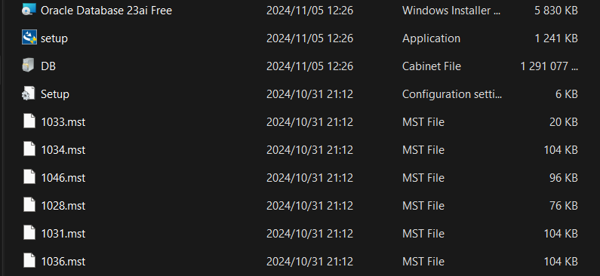

1. In the Specify Database Identifiers screen of the installation process, enter the Global database and the Oracle system identifier, SID. Don’t select the check box for the option Create as Container database. Click the Install button.
2. 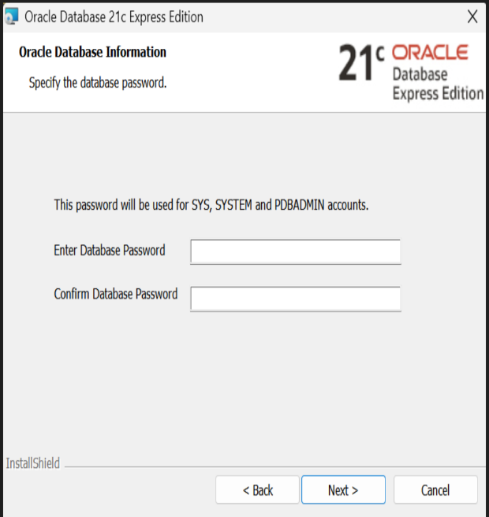A screenshot of a computer

   AI-generated content may be incorrect.Click Install to install the product. Oracle Database is installed on Windows.

Then wait

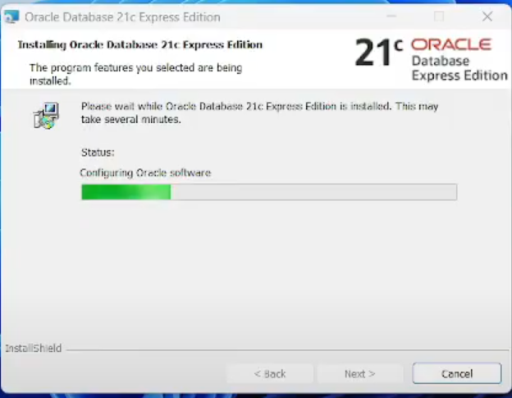

1. Start the SQL Plus application. From the command-line, enter the command SQLPLUS to start SQL Plus.

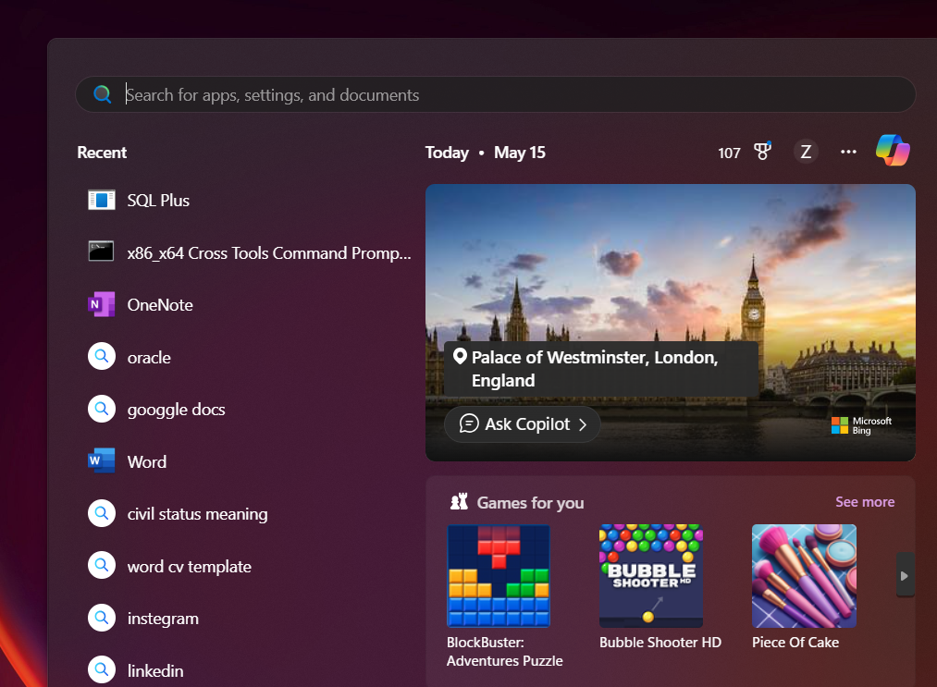

**Note: If You See "sqlplus is not recognized..."**

* It means the Oracle bin path is not in your environment variables.
* You can add it permanently:
  1. Right-click **This PC > Properties**
  2. Click **Advanced system settings > Environment Variables**
  3. Under **System Variables**, find Path > click **Edit**

*C:\app\oracle\product\19.0.0\dbhome_1\bin*

* 1. Click OK and restart Command Prompt.

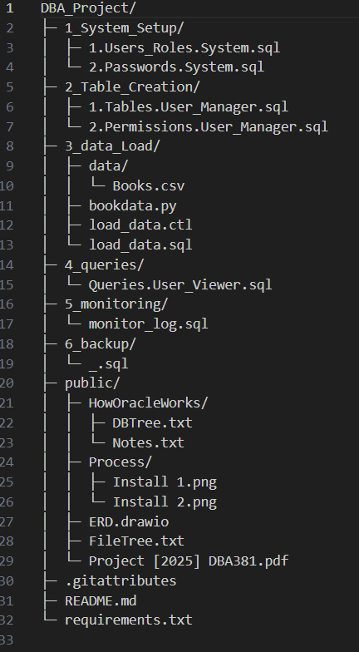

Oracle organizes data in one centralized database, while users, roles, and schemas are used to govern how people can access and use that data. XE from Oracle allows developers to set up a Container Database and a Pluggable Database named XEPDB1, which is an isolated workspace. The framework includes users who are allowed to sign in and own schemas, which contain all tables, views, procedures, and triggers. Creating roles groups together needed privileges and makes it easier to grant and reuse the same permissions for users.

Before anything else, you connect as the SYSTEM user Oracle’s default DBA account to establish a secure set up. SYSTEM instead handles users, roles, and privileges, but doesn’t make application data tables. Roles were generated from the SYSTEM schema to determine how much access each person or object would have: For people with just access, room for information is bookstore_read_only, for people who can add or alter articles, it’s bookstore_data_entry, and users on bookstore_manager can also use DDL to design tables and other objects.

Next, SYSTEM made severalusers and assigned them their Roles. User_viewer got the bookstore_read_only role as part of the setup. user_clerk now has the bookstore_data_entry role, and user_manager now has the bookstore_manager role. Every user was assigned the default USERS tablespace and given unlimited space to use for their objects in their schemas. User_manager was given additional privileges, such as unlimited tablespace, so they could handle and control the objects of the application.

With the users and roles arranged, the user_manager account was then used to set up the actual tables needed by the application. For instance, tblBook contains columns for a book’s ID, the title, and the price. Once the table was created, access was set up so that the bookstore_read_only could SELECT data, bookstore_data_entry could INSERT, UPDATE, and SELECT, while bookstore_manager could do everything, including DELETE.

By organizing things in this way, each user is restricted to their appropriate functions, guaranteeing the safety, accuracy, and administration of the whole system. It is built according to standards for schemas, permissions, and access in Oracle.

### 1.3 Configuration Adjustments

To configure Oracle database on Windows:

1. Log in to SQL*Plus application with sys as sysdba and the password you opt during the installation process in the Schema Password step.
2. Create the user and grant access to the database. The database name is the one that you set in [Installing Oracle Database on Windows](https://docs.oracle.com/en/java/java-components/advanced-management-console/2.25/install-guide/oracle-database-installation-and-configuration-advanced-management-console.html#GUID-B7AA0781-E0F9-41D3-8772-350F58501C3F).

Configure your Oracle database. If you encounter an issue with the SQL Create User statement, then log out of SQL*Plus application and repeat step 1 and step 2.

1. After you successfully create the user, exit the SQL*Plus application and log back into SQL*Plus as user. You are prompted to set up the password.
2. The Oracle Database user credentials provided in this topic are examples. The AMC doesn’t need to know your database user credentials. Oracle database user credentials are only required to configure the Data Source connection in the application server.

### Configuration Settings

During the Oracle Database setup using Database Configuration Assistant (DBCA), configuration settings were applied to ensure the database was optimized for the project's development needs:

# Organisational Requirements and Database Design

### 2.1 Organisational Requirements

An online bookstore which requires a database system to manage and streamline its core business operations.

* Management of Books: Store detailed information about each book, including title, author(s), publisher, publication date, price, and stock quantity.
* Author Information: Maintain a record of authors who can write multiple books.
* Customer Records: Track customer details such as name, address, and email for order processing and communication.
* Order Processing: Record customer orders, including order date and the customer placing the order.
* Order Details: Track each item in an order, including the book, quantity ordered, and price at the time of purchase.
* Relationships: Support many-to-many relationships between books and authors, and one-to-many relationships between customers and orders.
* Security: Control access to the database with user roles and privileges.
* Performance: Implement indexing to speed up queries on frequently accessed columns.

### 2.2 Schema

| **Entity** | **Description** |
| --- | --- |
| Book | Contains details such as title, publisher, publication date, price, and stock quantity. |
| Author | Stores author details including unique ID and name. |
| Customer | Contains customer information like name, address, and email. |
| Order | Records each customer order with order date and customer reference. |
| Order Detail | Captures individual items in an order: book ID, quantity, and price at order time. |
| BookAuthor (junction table) | Implements the many-to-many relationship between books and authors. |

2.3 Entity Relationship Diagram (ERD)

* Book–Author: Many-to-many relationship via BookAuthor junction table.
* Customer–Order: One-to-many relationship; a customer can have multiple orders.
* Order–OrderDetail: One-to-many relationship; each order can contain multiple order details.
* OrderDetail–Book: Many-to-one relationship; each order detail references a single book.

### 2.4 Table Descriptions

| **Table Name** | **Description** |
| --- | --- |
| tblBook | Stores book-specific data including title, publisher, publication date, price, and quantity in stock. |
| tblAuthor | Contains author ID and author name. |
| tblCustomer | Holds customer details such as name, address, and email. |
| tblOrder | Contains order ID, order date, and foreign key to customer. |
| tblOrderDetail | Contains details of books ordered (quantity, price) linked to orders. |
| tblBookAuthor | Junction table linking books to authors by their IDs. |

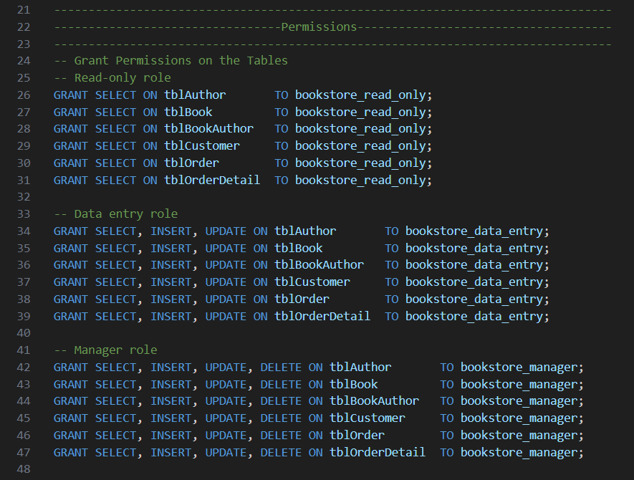

### 2.5 Views Created

| **View Name** | **Purpose** |
| --- | --- |
| vw_BooksByAuthor | Lists books along with their associated authors. |
| vw_CustomerOrders | Lists customers alongside their orders and order details. |

### 2.6 Indexes Created

| **Table** | **Column(s)** | **Purpose** |
| --- | --- | --- |
| tblBook | BookTitle | Speeds up searches and lookups by book title. |
| tblOrderDetail | (OrderID, BookID) | Enhances joins and lookups involving orders and books. |

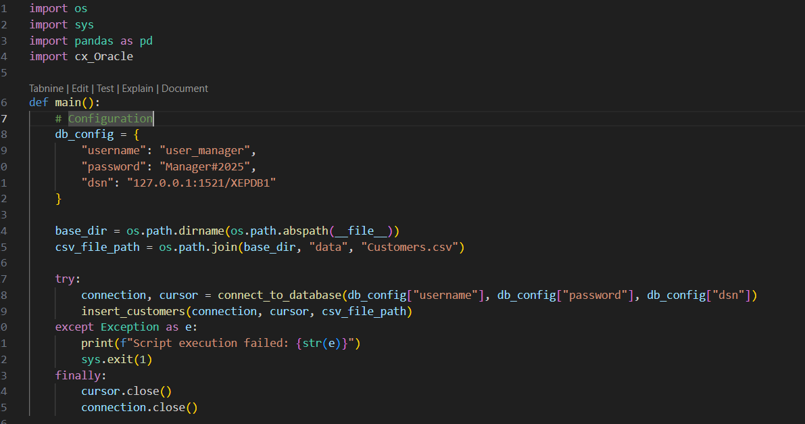

# Data Population and Query Execution

### Data Population Process

To populate the database with sample data, CSV files containing data for books, authors, and customers were used. Python scripts leveraging the **Pandas** library for data handling and **cx_Oracle** for Oracle database connectivity automated the data import process.

**Steps:**

1. **Data Cleaning:**  
   Before loading, the data was cleaned to remove duplicates, empty values, and special characters from book titles and author names. Publication dates were converted to Oracle-compatible date formats.
2. **Author Data Insertion:**  
   Unique authors were identified and inserted into the tblAuthor table. Existing authors were checked to avoid duplication.
3. **Book Data Insertion:**  
   Books were inserted into the tblBook table with fields such as title, publisher, publication date, price, and quantity.
4. **Author–Book Relationships:**  
   The many-to-many relationship between books and authors was maintained by inserting records into the junction table tblBookAuthor.
5. **Customer Data Insertion:**  
   Customer information was imported from the CSV file and inserted into the tblCustomer table.
6. **Transaction Management:**  
   All inserts were handled in transactions to maintain data integrity; any errors triggered a rollback.

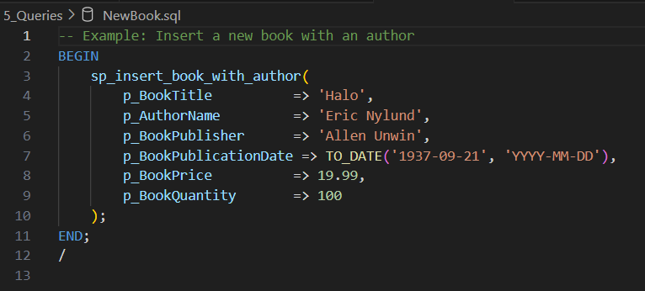

### Queries user_viewer.sql

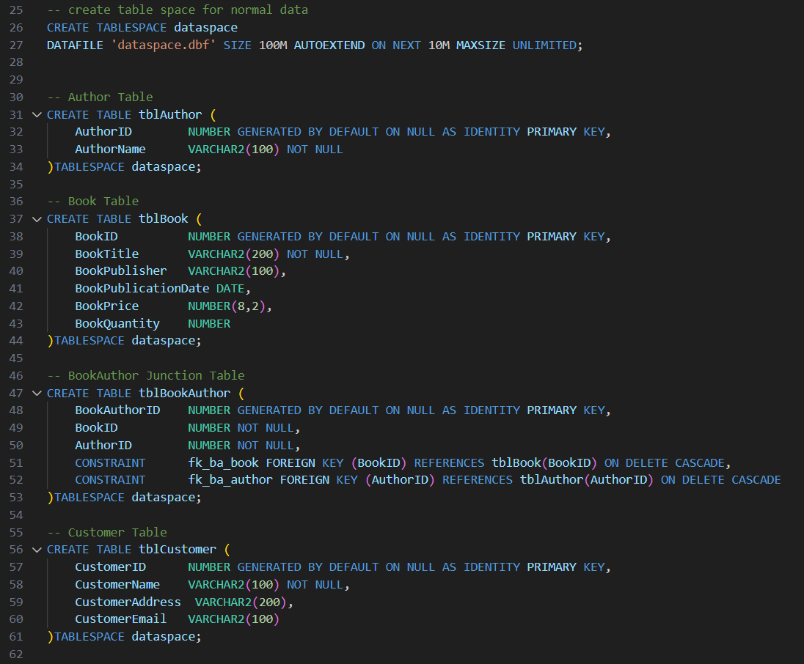

#### Explanation of the Procedure sp_insert_book_with_author

This stored procedure is made to reduce complexity and automatically add a book and its author to the database while keeping the data links between the three tables in place.

What It Does

Checks for Existing Author:

* Tries to discover the AuthorID for the name of the author.
* When the author does not exist, it adds the new author and stores their ID as the AuthorID.

Inserts the Book:

* Inputs all the required details into the book record.
* Captures the newly generated BookID.
* Links the Book and Author:
* Inserts a row into the tblBookAuthor table to match a book and an author.

Transaction Handling:

* After all the steps are successful, the smart contract completes the transaction.
* Should an error arise, the transaction will be cancelled, and the error is printed out using DBMS_OUTPUT.

Key Benefits:

* Stays in sync with the consistency and order of data in the database
* Prevents duplicate authors
* Stores frequently used multi-stage inserts in a common place.

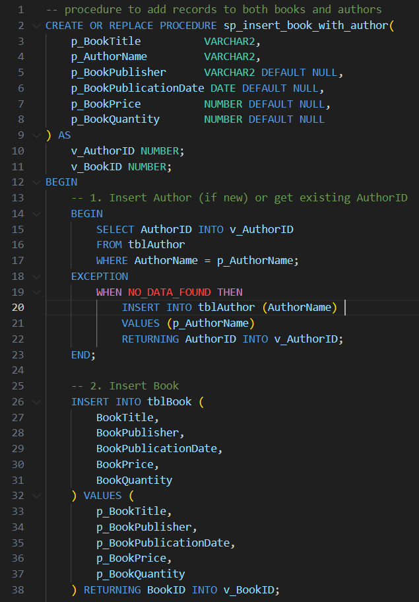

# Security Implementation

**To secure the database and control who can access what, roles, users, privileges, and password policies were created as layers for security. It’s designed according to Oracle’s approach where management tasks (SYSTEM) are apart from the tasks that involve application data (users/schemas).**

**Table.User_manger.sql**

**Permissions.user_manager.sql**

Security measures put in the database were making user accounts, setting up their roles and what they can do, and making sure everyone had good and safe passwords. Two users were created: book_admin can make changes in the books, while readonly_user can only read them. Corresponding roles were also created AdminRole gets all the permissions and ReadOnlyRole can only view data in the database. These roles were then given to the right people depending on what they needed to do in the organization. To further keep the system safe, rules were put in place so that passwords had to include a mixture of uppercase and lowercase letters, a number, and a special character. Additionally, passwords would have to be changed every 90 days, and if someone typed in the wrong password three times in a row, their account would get locked. These measures all worked together to make sure only the right people could get to the data and change it, while following the best rules for keeping things secure.

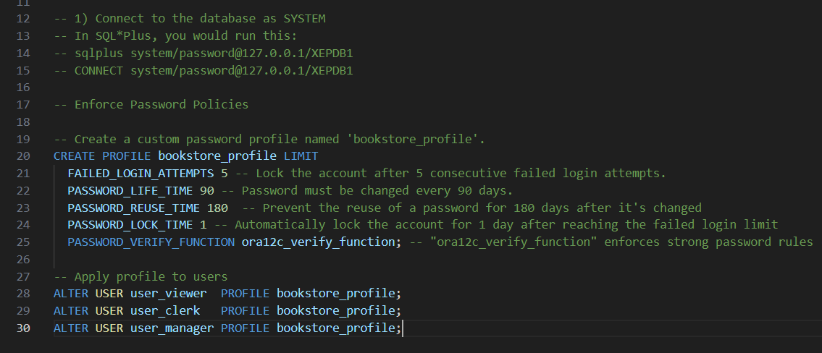

Note "ora12c_verify_function" enforces strong password rules (at least one uppercase, one digit, special char etc.)

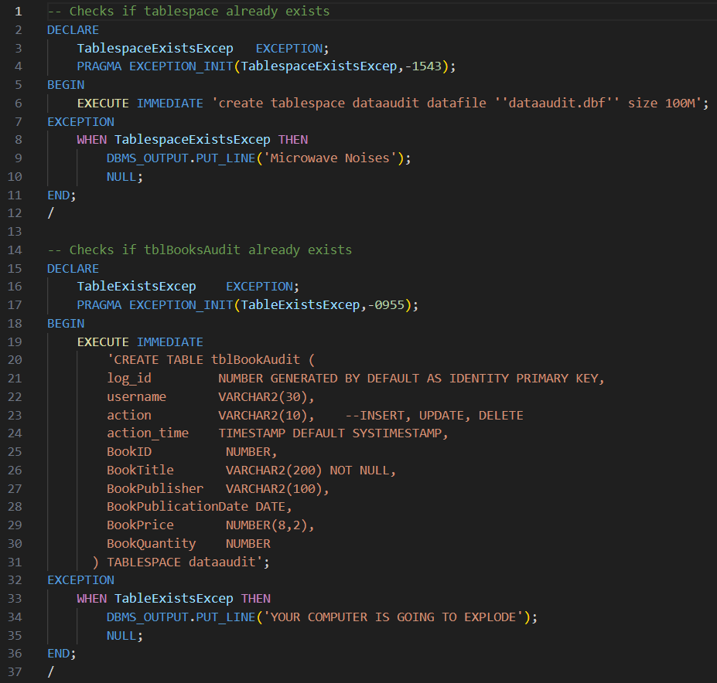

# Monitoring and Troubleshooting

To make sure the database was stable, available, and safe, several checks were done during the project. Regular checks with Oracle SQL Developer and by running queries on dynamic views like v$session helped me keep an eye on who was signed in and notice if anyone was trying to get in who shouldn't. Custom functions and rules were also set up to keep track of every change that happened to main tables like tblBook, and all the changes were saved in the tblBookAudit table in the dataaudit tablespace. This separation made it easier to handle the increasing amount of log data and helped the system work faster. During testing, we ran into a few little problems. One issue was that the queries on the tblBook table ran slowly, which got fixed by adding a new index on the BookTitle column. Another issue happened when the Oracle listener wouldn’t start, which was resolved by checking the listener.ora file and then simply restarting the service. Additionally, some users tried logging in more than once, but failed, which showed how important it is to have good, strong passwords. In response, a new set of rules was placed on all users, making sure that passwords were more complicated, changing them every 90 days, and locking accounts after a few wrong login attempts. These checks and quick fixes helped keep the database safe, fast, and well-working while it was being used.

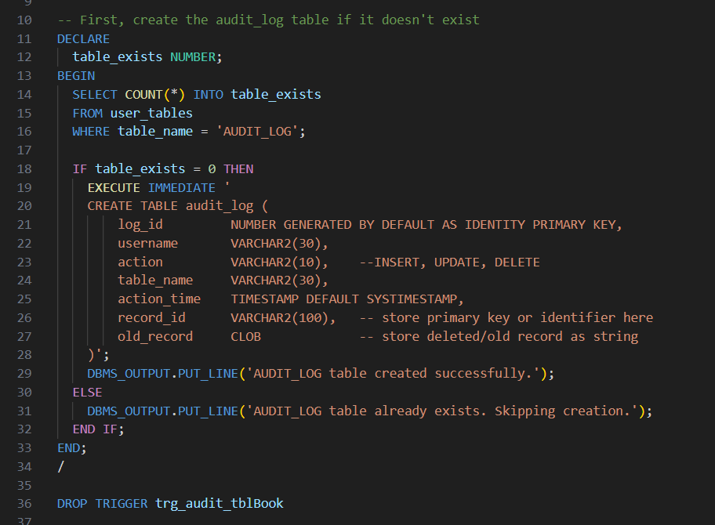  
The provided PL/SQL script implements an auditing mechanism to automatically log all changes made to the tblBook table. It begins by checking whether the audit_log table already exists, and if not, it creates the table with fields to store audit metadata—such as the user who performed the action, the type of action (INSERT, UPDATE, DELETE), the name of the affected table, the timestamp of the action, the record identifier (BookID), and a detailed snapshot of the previous record state stored in a CLOB field (old_record). Following this, a trigger named trg_audit_tblBook is created to fire **after** any insert, update, or delete operation on tblBook. When a change occurs, the trigger captures the current user and action type. For updates and deletions, it constructs a string containing the old values of the record, which is then stored in the audit table. This automated logging helps track data changes, supports accountability, and enables administrators to trace historical modifications for auditing and debugging purposes. The use of DBMS_OUTPUT allows feedback during table creation for easier development visibility.



# References

Oracle, 2023. *Oracle® Database Concepts 19c Release 3*. [online] Oracle. Available at: <https://docs.oracle.com/en/database/oracle/oracle-database/19/cncpt/index.html> [Accessed 16 May 2025].

Oracle, 2023. *Using SQL Developer*. [online] Oracle. Available at: <https://docs.oracle.com/en/database/oracle/sql-developer/index.html> [Accessed 16 May 2025].

cx_Oracle, 2023. *cx_Oracle Documentation*. [online] Oracle Python Driver. Available at: <https://python-oracledb.readthedocs.io/en/latest/> [Accessed 16 May 2025].

Python Software Foundation, 2023. *Python 3 Documentation*. [online] Available at: <https://docs.python.org/3/> [Accessed 16 May 2025].

Pandas, 2023. *Pandas Documentation*. [online] Available at: https://pandas.pydata.org/docs/ [Accessed 16 May 2025].

Stack Overflow, 2024. *Handling Oracle Triggers and Audit Logs*. [online forum] Available at: <https://stackoverflow.com/> [Accessed 16 May 2025].

W3Schools, 2024. *SQL Tutorial*. [online] Available at: https://www.w3schools.com/sql/ [Accessed 16 May 2025].